Operating Manual
EML 4551C
Dr. Amin

Team 4: Alternative material for compressor casing in turbocharger

Group Members
Oluwalowo Abiodun
Alexander Mankin- Team Webmaster
Harrison McLarty- Project Leader
Ralph Scott
Faculty Adviser
Dr. Peter Kalu
Sponsor
Cummins, Inc. – Roger England
Director, Advanced Manufacturing Technology and Materials Engineering
TABLE OF CONTENTS
1. Diagram and explanation of how a turbocharger operates 1
1.1 Functional Analysis of operation 1
1.2 Maximum performance conditions for compressor 1
2. Compressor casing prototype and mechanical properties 2
2.1 3-D printed prototype for demonstration 2
2.2 Material properties of casing based on selected alternate material (PEEK). 2
3. Brief outline for regular / routine maintenance 3
4.References 4

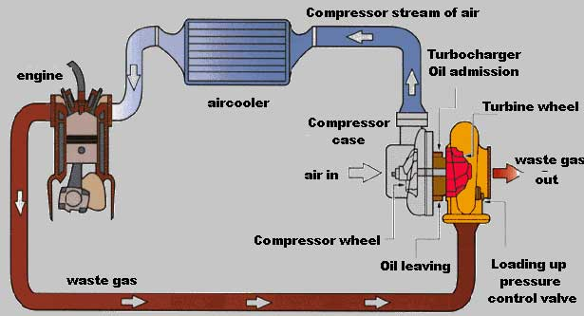
Diagram and explanation of how a turbocharger operates
Fig.1 Schematic of how a turbocharger operates and its different components. ¹

Functional Analysis of operation
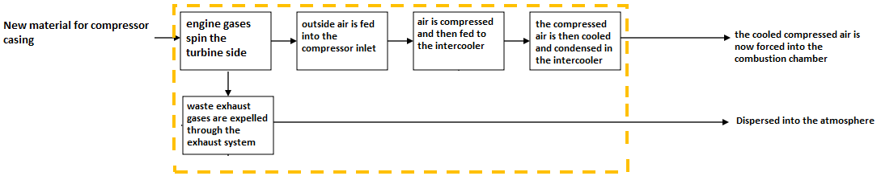
Fig.2 Functional analysis of how a turbocharger operates.

1.2 Maximum performance conditions for compressor
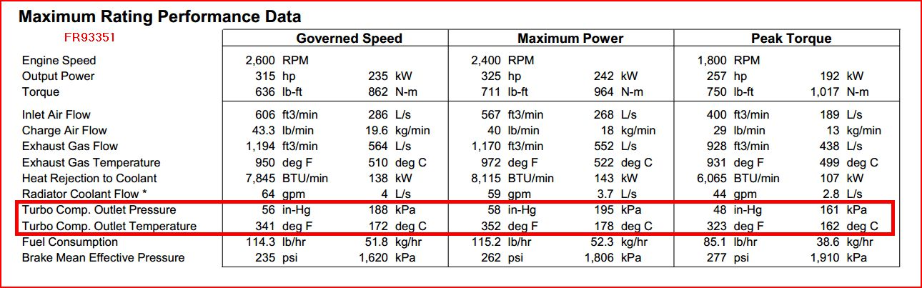
Figure 2. Experimental data of turbocharger supplied by sponsor.

Compressor casing prototype and mechanical properties

2.1 3-D printed prototype for demonstration
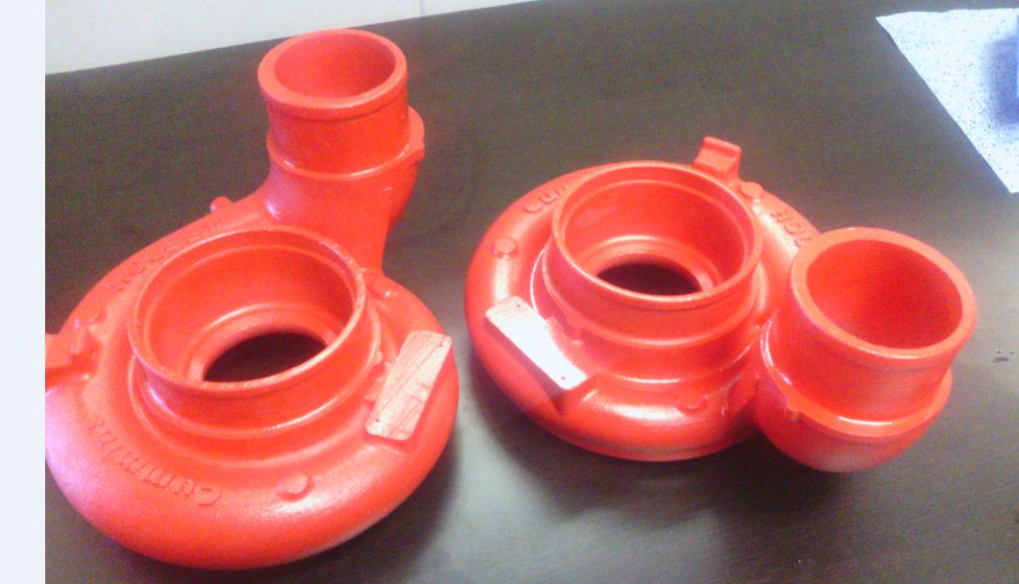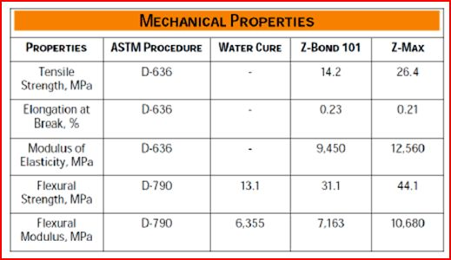
Fig.4 3-D printed compressor casing based on Z-max a proprietary material. (For demonstration purposes only).

2.2 Material properties of casing based on selected alternate material (PEEK).
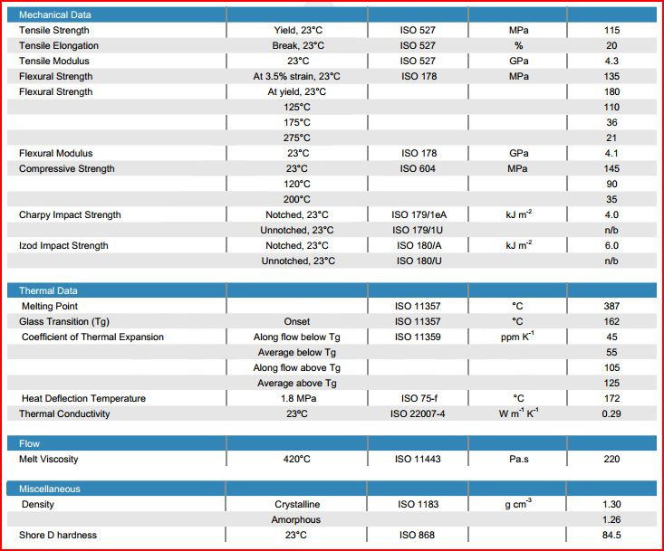
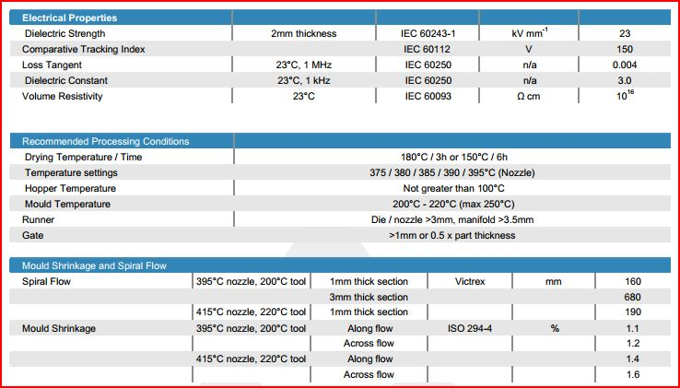
Fig.5 Material properties of PEEK obtained from Victrex for VICTREX® ${ST}^{TM}$ 45GL30.²

Brief outline for regular / routine maintenance
The routine maintenance that would be required for the turbocharger compressor casing would be very minimal. It would most likely include the following. After every other oil change interval, roughly 10,000 miles, it would require the operator to perform a visual inspection of the turbocharger compressor casing. The operator would check for any cracks or physical damage that compressor casing may have endured, which would result in loss of pressure and engine performance. Also the operator would check to make sure that both intake hoses are firmly secured to the casing and have come loose or been compromised in any way.

4.References
1. "Turbo Torque." Turbo Torque. N.p., n.d. Web. 21 Oct. 2013. <http://www.mazdarotary.net/turbo.htm>.
2. "Victrex.com." Victrex.com. N.p., n.d. Web. 27 Mar. 2014. <http://www.victrex.com/en/datasheets/datasheets.php?setUserId=91893&>.

